Manage Governance via Azure Policy

Lab Overview
This lab focuses on Azure governance using tags, Azure Policy, remediation, and resource locks.
You learn how to standardize resource configuration, enforce rules, and protect resources from accidental changes.
Estimated Time: 30 minutes
Region: East US
Governance Tools Used: Tags, Azure Policy, Resource Locks

Lab Scenario
Due to rapid cloud growth, your organization found:
- Resources without ownership or cost details
- No standard tagging enforcement
- Risk of accidental deletion

Governance Goals
- Apply consistent tags
- Enforce tagging for new resources
- Remediate existing resources
- Protect resources using locks

Architecture diagram
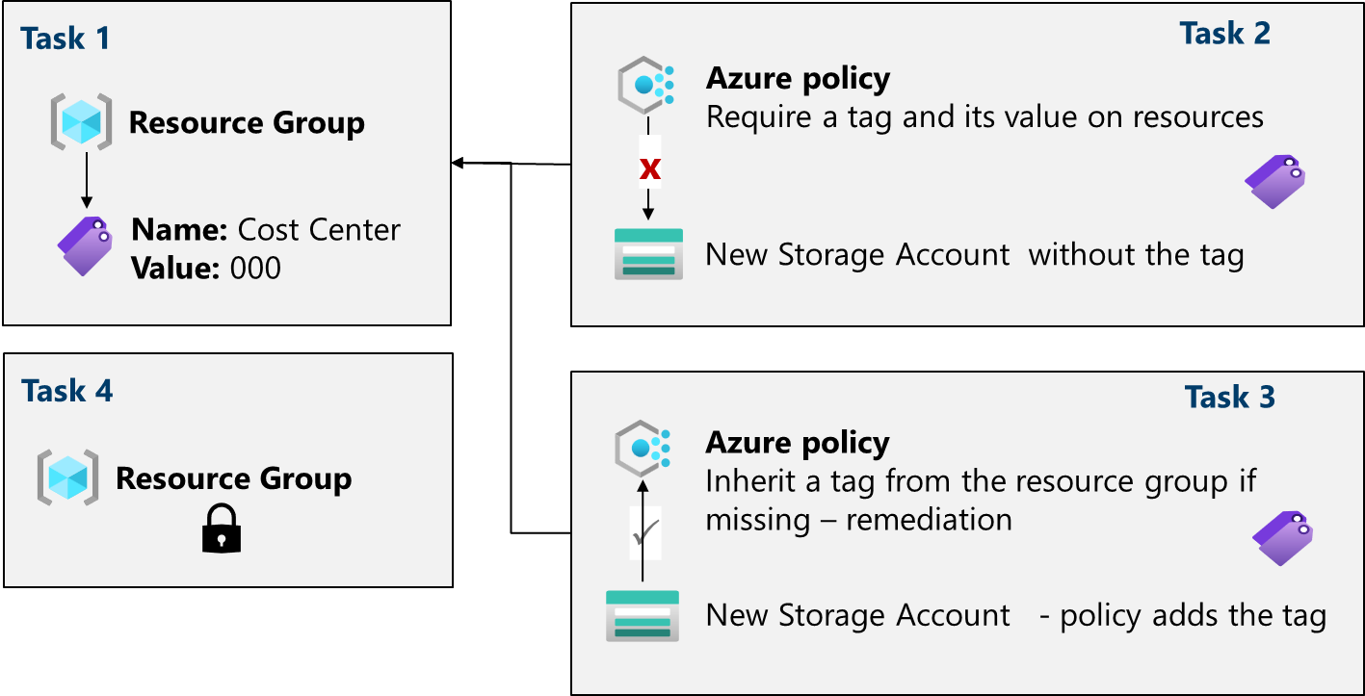

Job Skills Covered
- Assign resource tags
- Enforce compliance with Azure Policy
- Remediate non-compliant resources
- Protect resources with locks

Task 1 – Assign Tags via Azure Portal

Purpose
Tags add business metadata to Azure resources for cost management, ownership, and reporting.

Steps
- Sign in to https://portal.azure.com
- Search for Resource groups
- Select + Create

Resource Group Configuration
Setting | Value
Resource group name | az104-rg2
Region | East US

Add Tag
- Select Next → Tags
- Add the following:
Name | Value
Cost Center | 000
- Select Review + Create → Create

Task 2 – Enforce Tagging Using Azure Policy

Purpose
Ensure all new resources in the resource group have the required tag.

Steps
- Search and select Policy
- Select Definitions
- Search for Require a tag and its value on resources
- Review the policy and select Assign

Assign Policy
Setting | Value
Scope | Subscription → az104-rg2
Assignment name | Require Cost Center tag
Policy enforcement | Enabled

Parameters
Setting | Value
Tag Name | Cost Center
Tag Value | 000
- Skip remediation
- Select Review + Create → Create

Test the Policy
- Create a Storage Account in az104-rg2
- Do NOT add tags
- Validation fails due to policy enforcement
Result:
Deployment blocked by Azure Policy.

Task 3 – Apply Tagging via Azure Policy (Remediation)

Purpose
Automatically add missing tags instead of blocking deployment.

Steps
- Go to Policy → Assignments
- Delete previous Require tag policy
- Select Assign policy

Assign Inheritance Policy
Setting | Value
Policy | Inherit a tag from the resource group if missing
Scope | az104-rg2
Assignment name | Inherit Cost Center tag

Parameters
Setting | Value
Tag Name | Cost Center

Remediation
- Enable Create a remediation task
- Managed Identity auto-created
Select Review + Create → Create

Test the Policy
- Create a Storage Account without adding tags
- Deployment succeeds
- Tag is automatically inherited from the resource group

Task 4 – Configure and Test Resource Locks

Purpose
Prevent accidental deletion or modification of critical resources.

Steps
- Open az104-rg2
- Go to Settings → Locks
- Select Add

Lock Configuration
Setting | Value
Lock name | rg-lock
Lock type | Delete

Test Lock
- Attempt to delete resource group
- Deletion fails due to lock

Cleanup (Optional)

Portal
- Remove lock
- Delete resource group

PowerShell
Remove-AzResourceGroup -Name az104-rg2

CLI
az group delete --name az104-rg2

